Load dealers

CREATE OR REPLACE PACKAGE pkg_load_ext_ref_dealers

AS

PROCEDURE load_dealers;

END pkg_load_ext_ref_dealers;

/

CREATE OR REPLACE PACKAGE BODY pkg_load_ext_ref_dealers --

AS --

PROCEDURE load_dealers --

AS --

CURSOR c_d --

IS --

SELECT DISTINCT d.dealer_id

, d.dealer_name

, d.dealer_address

, c.capital_id

FROM u_sa_data.tmp_dealers d join u_sa_data.tmp_capitals c on d.dealer_city = c.capital

WHERE d.dealer_id NOT IN (SELECT d.dealer_code

FROM u_dw.t_dealers d);

BEGIN --

FOR i IN c_d LOOP --

INSERT INTO u_dw.t_dealers ( dealer_id

, dealer_code

, city_id

, dealer_name

, dealer_address

, insert_dt )

VALUES ( u_dw.sq_dealer_id.NEXTVAL

, i.dealer_id

, i.capital_id

, i.dealer_name

, i.dealer_address

, SYSDATE );

EXIT WHEN c_d%NOTFOUND; --

END LOOP; --

COMMIT; --

END load_dealers; --

END pkg_load_ext_ref_dealers; --

/

BEGIN

pkg_load_ext_ref_dealers.load_dealers;

END;

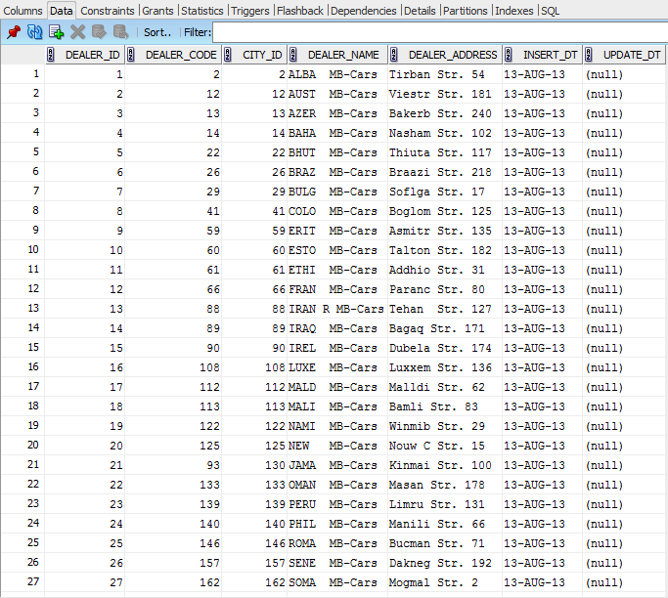

**Module clause**

/* Formatted on 8/13/2013 12:12:58 PM (QP5 v5.139.911.3011) */

SELECT vehicle_type_desc

, vehicle_desc

, fct_quantity AS quantity

, round(fct_amount) AS sales

FROM delivery

WHERE dealer_country = 'Germany'

AND event_dt >= TRUNC ( TO_DATE ( '01-jan-2013'

, 'dd-mon-yyyy' )

, 'month' )

AND event_dt <= (TRUNC ( TO_DATE ( ADD_MONTHS ( TO_DATE ( '01-jan-2013'

, 'dd-mon-yyyy' )

, 1 ) )

, 'month' )

- 1)

GROUP BY vehicle_type_desc

, vehicle_desc

MODEL

DIMENSION BY ( vehicle_type_desc, vehicle_desc )

MEASURES ( SUM ( fct_quantity ) quantity, sum ( fct_amount ) sales )

RULES

( quantity ['TOTAL FOR vehicle_desc'

, FOR vehicle_desc IN

(SELECT DISTINCT vehicle_desc

FROM delivery

WHERE dealer_country = 'Germany'

AND event_dt >= TRUNC ( TO_DATE ( '01-jan-2013'

, 'dd-mon-yyyy' )

, 'month' )

AND event_dt <= (TRUNC ( TO_DATE ( ADD_MONTHS ( TO_DATE ( '01-jan-2013'

, 'dd-mon-yyyy' )

, 1 ) )

, 'month' )

- 1))] =

SUM ( quantity )[ANY, CV ( vehicle_desc )],

sales ['TOTAL FOR vehicle_desc', FOR vehicle_desc IN

(SELECT DISTINCT vehicle_desc

FROM delivery

WHERE dealer_country = 'Germany'

AND event_dt >= TRUNC ( TO_DATE ( '01-jan-2013'

, 'dd-mon-yyyy' )

, 'month' )

AND event_dt <= (TRUNC ( TO_DATE ( ADD_MONTHS ( TO_DATE ( '01-jan-2013'

, 'dd-mon-yyyy' )

, 1 ) )

, 'month' )

- 1))] =

SUM ( sales )[ANY, CV ( vehicle_desc )],

quantity ['GRANT TOTAL', NULL] =

SUM ( quantity )['TOTAL FOR vehicle_desc', ANY],

sales ['GRANT TOTAL', NULL] =

SUM ( sales )['TOTAL FOR vehicle_desc', ANY] )

ORDER BY vehicle_type_desc

, vehicle_desc;